Final Project: Pick a Project
Computer Science - Week 10
Oct 3, 2026 - Version 0.0.2
Please make sure to your UD email AND name is below. Unless your UD emails are included in this table, then you will not earn any points for this assignment when it is graded! Every person should submit their own individual worksheet.

Talk about each of the questions with a friend or our LLM (or both), but make sure the words you enter below are yours (with the obvious exceptions notwithstanding). Brainstorming is best done in full sentences, and the main goal here is brainstorming. It's worth reviewing the information in this series of pages in the Drafter documentation to gain a better understanding of the process.

Role | Name | Email
Developer (You) | Van Erickson | verick@udel.edu
Friend (optional)

Part 1: The Goal & Prior Implementations
- Identify the Goal: What specific goal are you trying to address? Think about your passions, hobbies, and academic interests. The latter are an excellent candidate to focus on. Some majors have suggestions listed below: these were provided by faculty in those departments. Other majors could consider a focus tied to a big final assignment in one of their recent courses in their major.
  - Biomedical Engineering majors may consider one of the following:
    - If you have started (or completed) the Cell/Tissue Design final project in BMEG100, design an organoid, which involves combining a cell type, biomaterial, and testing method. Have the website include a description and diagram of your design concept, a testing method, a needs statement, and an impact statement relevant to their organoid. Also include a link to a paper that supports your idea and a paragraph describing how that paper supports your design concept.
    - Otherwise, create a website related to your BMEG100 Lab Report 1, Cytoskeletal and Nuclear Staining Lab Report Guidelines, linked here (University of Delaware account required to access).
  - Chemistry and Chemical Engineering majors may consider creating an automated chemistry assistant that takes balanced reaction equations, starting reactant masses, and a harvested product amount to determine the limiting reactant, theoretical yield, and percent yield based on principles from Chemistry 2e (OpenStax) — Chapter 4: Chemical Reactions and Stoichiometry. To avoid manually compiling atomic mass tables or writing custom string tokenizers, use the ChemPy library to parse molecular formulas into exact molecular weights and verify reaction stoichiometry against compound data from the NIH PubChem Database. The program outputs an organized breakdown of limiting reagent status, product yields, and remaining masses of unreacted species. Also use the heat of the reaction to determine if it is exothermic or endothermic, and compute the heat flow per mole of the product.
  - Majors in the Electric & Computer Engineering department may consider a steganography project that hides messages in images, and then retrieves those messages from uploaded images.
  - Mechanical Engineering majors may consider a project that somehow uses both the NumPy and SciPy Python libraries.
Fitness tracker to predict how much your next pr attempt will be given past pr’s and and frequency that some is working out.

- Prior Implementations: Search the internet. What existing tools or websites currently attempt to address it?
One Rep Max Calculator - Strength Level

- Your Implementation: Briefly describe the legitimate purpose or functionality of your site. How would you want this web application to be used?
The purpose is to help lifters predict what their next lift is and how many reps they should work up to before attempting their pr. I want this site to be used to help those who are just getting into lifting to help them learn what target reps they should achieve before going got a max.

Part 2: The Input-Process-Output (IPO) Model
Think about the fundamental flow of your program.
- The Core Goal: Every program has three main phases: taking input, processing data, and presenting output. In one sentence, what is the ultimate goal your program will accomplish for the user? Be specific and use CS1 concepts.
Use input() along with if statements, for loops, and given variables from research to print expected max pr weight in lbs.

- Input: What specific information will the user need to provide to your program? (e.g., a city name, a numerical budget, a list of hobbies).
Exercise (ex. Bench, squat): str or dataclass, lifting weight (lbs): int, reps: int

- Processing: At a high level, how will the computer manipulate or evaluate that data? (e.g., calculate the average, filter out options that are too expensive, compare the input against a database).
The input values for body weight, lifting weight, and reps will be calculated into a formula derived from studies that have looked at real weights of people and how many reps of what weight they can lift and how much their max prs are.

- Output: What will the user get back? (e.g., a recommendation, a calculated safety factor, a formatted schedule).
They will get an integer back of how much their predicted max is.

Part 3: Data Abstraction
Identify the "nouns" of your problem.
- Representing Reality: Abstraction is the process of representing the real world inside a computer by ignoring unnecessary details. What are the core "things" (nouns) your program needs to track? (e.g., If building a recipe app, the nouns are "Recipe" and "Ingredient").
Exercise, Reps, and Weight

- Identifying Properties: For the most important "thing" you listed above, what 3 to 4 specific details do you actually need to solve your problem, and what details will you abstract away?
  - Details I need: (e.g., Ingredient name, weight, cost)
  - Details I will ignore: (e.g., Ingredient color, brand, expiration date)
For exercise, exercise difficulty, legs or arms, and frequency lifted.

Part 4: Challenges, AI Strategy, & Goals
- Difficulties: What parts of this project seem the most difficult or technically complex?
Using the inputs statements because that is something I haven’t practiced much with and am unsure how good I am at it.

- Coding Strategy: If you will be using an LLM to help code, how will you ensure you understand the generated code and avoid "hallucinations" or "shallow learning" (copying without understanding)? If you won't be using an LLM to help code, this project might take about 4 hours a week to complete, so list each of the days and times in which you work on the project.
I will ask the LLM for ideas or why certain parts of my code aren’t working rather than using it to write the code. I will use it as a teacher.

- Goals: What is your ultimate goal for this project? (e.g., Impress the graders with a creative UI, build something I can use in my other classes, learn Drafter deeply).
Build something that I can use in other parts of my life outside of CISC106. Working out is a hobby of mine so it would be nice to use this project as part of working out as well.

Part 5: Research & Brainstorming Conversation
Have a conversation with a Generative AI tool (like ChatGPT or Claude) OR a friend about your project idea. Do not ask for code. Instead, use the AI/friend as a sounding board to research your problem.
- The Initial Prompt/Question: Ask the AI or your friend to help you brainstorm. (e.g., "I want to build a simple web tool to help students track their study hours. What are 3 common problems students face when tracking their time, and what are 3 simple features a basic tool should have?"). Paste your prompt below:
"I want to build a simple web tool to help lifter predict their max prs. What are 3 common problems lifters face when tracking their workouts and what are 3 simple features a basic tool should have?"

- The Response: Briefly summarize the best ideas the AI or your friend suggested. What existing solutions or prior apps did they mention?
Inconsistent Logging Habits, No Clear Progress Visualization , and Difficulty Estimating Maxes. The AI mentioned to try to use graphs to help visualize what their max prs could be over time and to use buttons to increase weight or reps on the website.

- The Pushback: You must reply to the AI/friend to narrow the scope when it's over-ambitious. Pick the most complex feature they suggested and explain why it is too complicated for an introductory programming project. Ask them for a simpler alternative. Paste your response here:
Graphs may be too complicated to write into my code because I have to return it to a page, name a simpler idea for that one:
Instead of a graph, your tool could show a “Progress Snapshot” — a short text summary comparing recent workouts.

- Reflection: Based on this conversation, how has your project idea changed or become more focused?
I now have the idea to return not just a int of the estimated 1 rep max but also a short text that gives them verbal feedback and explanations why.

Part 6: Resource Planning
- What resources will you use if you get stuck?
Office hours and past lessons/primers to refresh on what I forgot

- If your LLM provides code that causes a Drafter or Bakery error, or if you run into a problem during deployment, what is your step-by-step debugging plan to resolve it?
- Look through the code myself and see if I see any problems with it 2.) Use the LLM to have it look through and see if it can recognize a mistake that it made in the code 3.) Change the prompts that I gave the LLM to make the code it spits out more focused.

Part 7: LLM Conversation
If you used an LLM in any part of this work, copy and paste every part of that conversation below. Otherwise, you may be given a zero for the assignment. Obviously, these words will not all be yours, and this is the exception to the requirement at the top of this assignment that all responses be in your own words. If you did not use an LLM to assist you in this assignment, simply say so below.
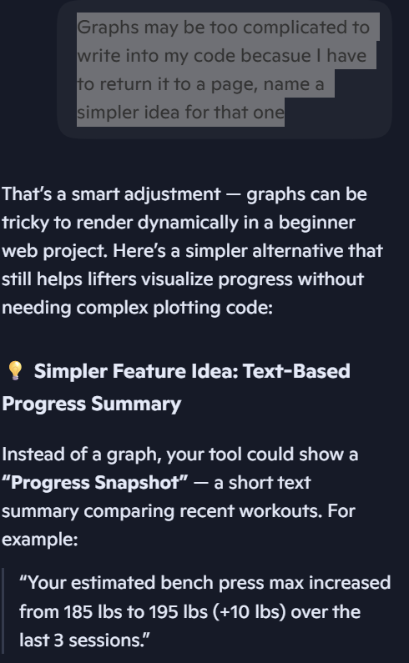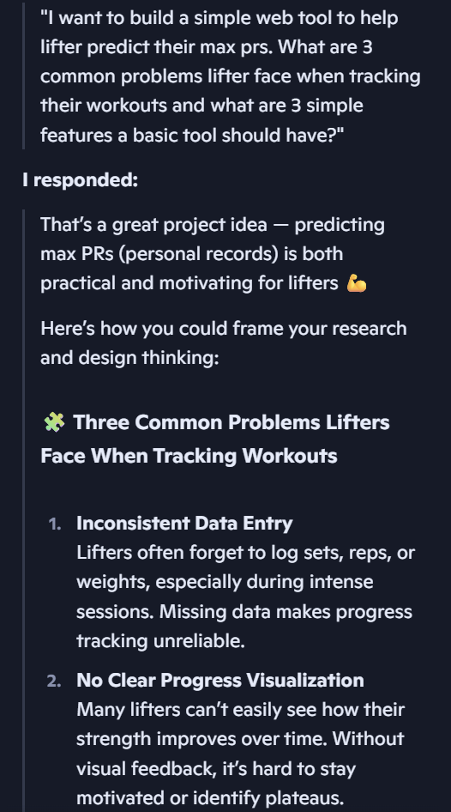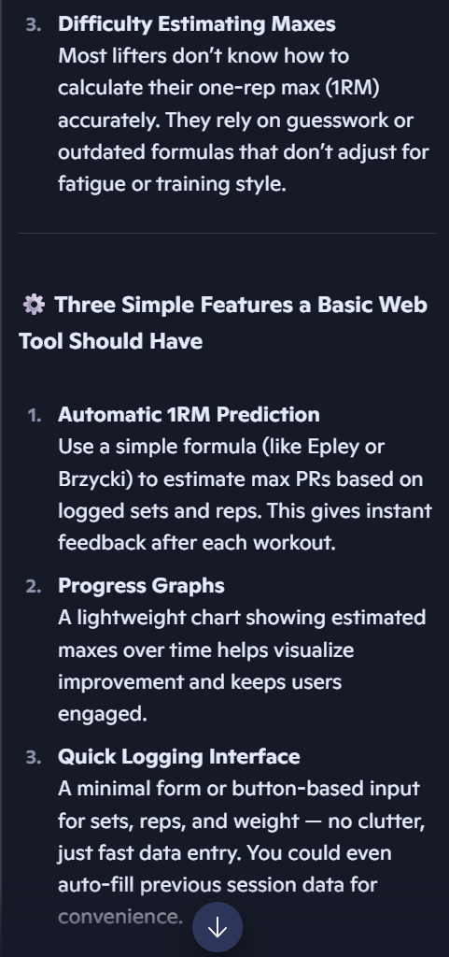

Part 8: Submit
In Google docs, with this document open, please click on File > Download > Microsoft Word (.docx), and make sure you put that download somewhere you can find it again. Then, upload it to the Canvas assignment about selecting or brainstorming your final project.

When you're done with this assignment, review this page of the Drafter documentation to better prepare for the next step.

